IoT Based Precision Agriculture using Wireless

Sensor Networks

|  |  |
| --- | --- |
| Prashant Walunj  School of Computer Engineering and  Technology  MIT Academy of Engineering  Alandi, Pune 412105  Email: pvwalunj@mitaoe.ac.in | Arjun Yachwad Mangesh Gund  School of Computer Engineering and School of Computer Engineering and  Technology Technology  MIT Academy of Engineering MIT Academy of Engineering  Alandi, Pune 412105 Alandi, Pune 412105  Email: amyachwad@mitaoe.ac.in Email: mdgund@mitaoe.ac.in |
| Chaitanya Barsawade  School of Computer Engineering and  Technology  MIT Academy of Engineering  Alandi, Pune 412105  Email: cmbarswade@mitaoe.ac.in | Prof. Santosh T. Warpe  School of Computer Engineering and  Technology  MIT Academy of Engineering  Alandi, Pune 412105  Email: stwarpe@comp.maepune.ac.in |

***Abstract*** *-* **Agriculture**​ **plays a significant role in the economic development of India; therefore, we need to carry out new technologies for Precision Agriculture. Manual methods for soil analysis give inaccurate values because there is a difference between soil samples at the field and measuring in the laboratory with technologies. In India, it is required for automated distribution of fertilizers and technologies because most of the farmers use traditional types of farming, which gives less amount of productivity concerning intense hard work and efforts. The productivity of India is less as compared to other countries. To enhance productivity and profit margin, the adaptation of new technologies can help us to a great extent. So, this paper is based on a survey of Wireless Sensor Network because these technologies are useful for the quality and standard of agriculture. This paper presents the study of Wireless Sensor Network that can be suitable for agriculture for automated farming. This paper will suggest the farmers make the proper choice, obtain superior output, and be economically strong.**

***Index Terms - Wireless Sensor Network, Precision Agriculture, Soil Nutrient, Crop Productivity***​**.**

1. **INTRODUCTION**

Soil Analysis is one of the valuable tools in the Agriculture field for yielding good crops. Soil Analysis helps farmers to determine the values of nutrients required for effective and profitable production. Most soil usually has a very high stock of nutrients. But whenever a new crop gets harvested, the nutrients in the soil get used for crops because low nutrition growth of crops doesn't happen properly. To yield superior crop production, the nutrients should be rebuilt in the ground. Hence farmers require to know the correct proportion of Nitrogen, Phosphorus, and Potassium.

In the 21st century, Farmers need to use precision farming to improve their crop yields. To calculate the ratio of NPK, we are using the Wireless Sensor Network nodes. These notes are placed at a specific distance so we can get precise calculations of NPK values. But for big farms, we will need a massive number of nodes. So, to overcome this problem, we are using the cubic spline method, which is a type of interpolation. In this, we can evaluate a method of forming new data points within the range of known data points. By this method, we can minimize the nodes so it will be economical for farmers.

1. **WIRELESS SENSOR NETWORK**

Wireless Sensor Network has come up with new technology that assists the growth of the quality of agriculture. WSN Network including sensors and microcontrollers to procedure the details, base station to transmit or receive the information from nodes. WSN technology has huge trends in today's world for the growth of superior agriculture. WSN technology requires low utilization of power and various functions of nodes. Nodes placed or situated at various positions that feel the numerous surroundings parameters at respective places and do further procedure according to the data. Sensor nodes can monitor parameters like soil fertility, pressure and thermal, temperature, audio, moisture, intensity, rotation, and touch, etc. WSN has a massive range of applications when agriculture comes into the picture. WSN is used in various industries and military areas. In the agricultural field, WSN is used for real-time monitoring of data on the field. In our case, it will be used to monitor the values of NPK fertilizer.

2.1 NPK Fertilizers

There are six essential nutrients like Nitrogen (N), Potassium

(K), Phosphorus (P), Magnesium (Mg), Sulfur (S), Calcium (Ca) that helps to grow plants. They help to create new cells. Out of this, NPK is the most required nutrient for plants. Nitrogen is responsible for giving plants green coloring. Phosphorus helps to grow roots and fruit development. Potassium also plays a part in root growth as well as stem development. So determining the NPK value of the soil will help in calculating the optimal value of the fertilizer required.

# ARCHITECTURE DESIGN

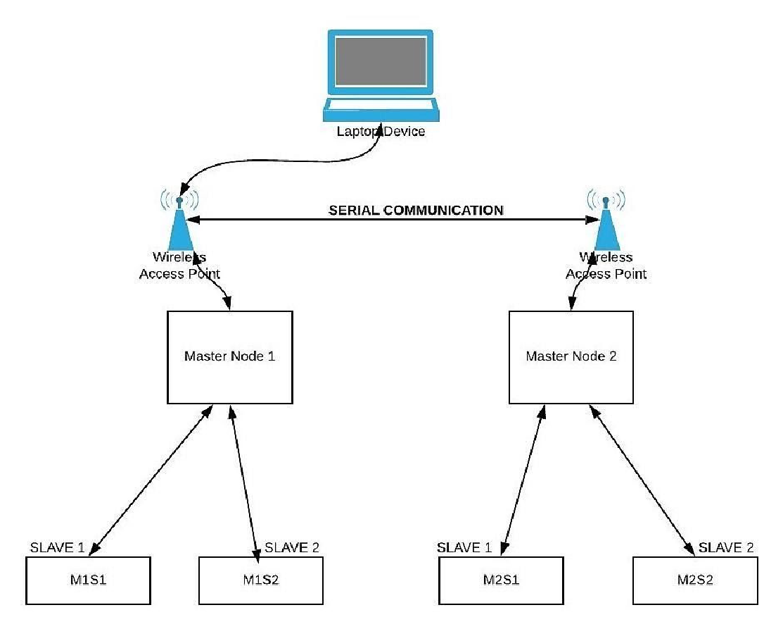

Fig. 01 – System Architecture

In the given fig, we are using two master nodes and four slave nodes and one base station. Each master node connects to two slave nodes. The slave nodes of master node M1 called M1S1, M1S2, and other slave nodes of Master M2 are called M2S1 and M2S2. All slave nodes send data to their respective master nodes M1 and M2 for Sensing, collecting, storing, and then clarifying the captured data and transfer that data to the specific base station.

# LITERATURE REVIEW

V. Grimblatt et al. [1] proposed that the IoT solution can be used for precision agriculture. He showed the system that can use low energy to communicate to the node to sources.The information can be received and relevant information can be sent to the cloud for further statistical analysis.

S.Bhanumathi et al. [2] There are many attributes that are there like the location of the farm, pH values by which we can define the how soil is alkaline. With that, there is the finding of the percentage of nutrients like values of NPK, which are Nitrogen, Phosphorus, Potassium are used. The applications can be used like APIs for finding the Temperature and Weather, Type of Soil, Nutrients in the soil, Value of Nutrients in the ground, percentage of rainfall in a particular part of the region, the composition of soil can be determined.

J. P. Kumar et al. [3] developed a quantification eq. Between the fertilizer concentration and diagnostic depths in the soil. The demanding task was to confirm whether the developed equation Remains valid for low to deficient concentrations of fertilizers.

M. Masrie[4] show that the optical sensor developed by the author was able to detect the NPK values in soils. The responses of output for high NPK found at Nitrogen 32.0V, Phosphorus 4.6V, and Potassium 19.8V.

R. Sumiharto et al. [5] proposed the backpropagation algorithm consisting of gathering soil image datasets, pre-processing, feature extraction, and training the neural network model.

NS Gill and ML Verma et al. [6] shows that tomato crop NPK values are detected in various seasons and various types of soil. Analyze crop NPK under different treatments without fertilizer.

K. K. Ghanshala et al. [7] proposed a system that can be used for monitoring crops smartly with the help of the Internet of things (IoT). He showed the four-step framework. He used data from the cloud, data from the sensor, base station, and sending device. In this method, the analysis of soil nutrients like values of NPK is done. Also, the moisture of soil, temperature, and humidity can be measured.

Mohammad Shareef Mekala et al. [8] In this paper reviews the use of the energy-efficient sensor. And also an efficient selection of a virtual machine for IoT based applications. It explains the scheduling of virtual machines, proper architecture, measuring functions. In this paper, firstly technical measurement of variables is taken and then finding the difficulties in the selection of sensors, communication problems because of sensors.

Madhura U K et al. [9] proposed that NPK, Electrical conductivity. The ph of soil using Arduino UNO. In this, they use a sensor node application, in which sensors are connected to multiple sensors and one gateway node which receives data from sensors. For remote use, they use a battery, solar panel, boot converter to better service at any moment and can charge continuously and get electricity. Use a GSM module for accessing the cloud.

S.N.Shylaja et al.[10] proposed that there are many chemicals present in the soil. When we drop the sensor in the soil, there will be many chemical reactions. Which can change the deflection of our analog meter indeed changing the output results. So here the mapping of these NPK values is done in this paper**.**​

John Carlo Velasco Puno et al. [11] they determine the pH level of soil and six essential nutrients that are discussed above using ANN Network with the help of MATLAB. The system consists of image processing, image capturing, testing of soils and training system for ANN network. With the help of the system they recommend the fertilizer for a specific crop that will be found while testing of soil.

Dr. Manish.B.Giri et al. [12] they mainly use wireless network sensors for predicting NPK, moisture, humidity values of soil. They use master and slave nodes to cover the maximum field and get results on the field at that time. WSN reduces human effort and reduces electricity use as it can identify moisture, humidity using sensors.

Santosh Warpe et al. [13] paper presents a study of the WSN network, which suggests required fertilizer for particular crops with less human effort and maximum profit. The WSN network helps farmers to offer optimum fertilizer using smart farming.

Amrutha A et al. [14] shows that chemical methods and algorithmic methods (by using microcontroller, sensor, etc.) differ. Lab testing requires a few days, and an algorithmic process done in 30min. Describe farmer issues and provide a solution for the automatic detection of soil by reducing labor and time.

Jin-Hyuk Chun et al. [15] show the effect of NPK fertilization on rocket salad vegetables. It analyses different ratios of NPK to improve the quality of GSL levels. Rocket salad has a higher concentration of K and less with N and P, which show improvement of GSLs contents. N concentration over 5mM and K concentration smaller than 2.5mM, the GSL level amount was on a mean of 13.51.

Dhanapriya.M, Maheswari.R et al. [16] analyses the content of micronutrients and macronutrients that exist in the soil; The quantity of nutrients available to roots is the main factor in producing crops. It analyses that macronutrients and micronutrients are essential to the growth of plants. Macronutrients like N, P, K needed in large amounts.

L.E.D. Smith, G. Siciliano et al. [17] explains the much more use of fertilizer observed in the farming system in china. The efficient use of fertilizer and water resources improves the agriculture field, food safety. Overall, it shows that it requires improving the mitigation framework that holds central policy directives.

Terry L. Roberts et al. [18] analyses how cadmium affects human health; The main effect of cadmium on human health is kidney disease. Cadmium found in all agriculture soils i.e., Phosphate rocks. Levels of cadmium in agriculture soil can increase through atmospheric deposition like forest fires, soil erosion, and air pollution. So, there is some limit to add Cd in P fertilizers. Scientific literature suggests that Cd would accumulate through p fertilizer in soils should less than 60mg Cd/kg P2O5, which leads to much less human health risk.

Mohamed Rawidean Mohd Kassim et al. [19] this paper, they use WSN in the greenhouse using IoT based technology. They compare their result with the threshold values of the crop. The article shows that automated irrigation is efficient than scheduled irrigation.

Alfredo Aires et al. [20] shows how nitrogen and sulfur fertilization impact on glucosinolates in specific plants such as broccoli, cabbage, mustard. Overall, it means the effect on some pungent plants. It analyses that broccoli sprouts did not require N and S fertilization to improve GSLs levels. It is essential to improve GSLs levels for pungent plants to grow.

# EXISTING SYSTEM

Climate change is continuing to impact on agriculture and crops. Impact of climate and weather, people must begin to transform the way we adopt such changes. To enhance and maintain food security and the growth of crops in the field, we need a transformative adaptation in agriculture. Therefore, to improve the growth of crops and crop productivity, we need to examine the NPK values of a particular soil, which can suggest the right fertilizer. In rural areas, farmers can determine the maturation and growth of crops, and by applying their experience, they can conclude how much fertilizer is supposed to use for specific soil. But the case is that proportion is not always correct for all crops. So, there are many existing systems to determine the NPK values of earth and suggest the right balance of fertilizer that is needed. Newton's Forward Difference (NFD) Method used for the distribution of fertilizers to crops.

The Identification steps involved are:

* Setup sensors and nodes: Putting all the detectors such as Master and Slave in the field at actual points, using the NPK sensor to determine the NPK values.
* Image Acquisition and Analysis: Capture the image of the NPK sensor where we are getting combined values of NPK.

Sending wireless signals: The captured image of the NPK sensor now forwarded to the base station.

* Analysis of NPK values: Combined values are separated and compared with the standard prices of NPK for a given crop.

# CONCLUSION

This paper presents a study of WSN that provides fertilizer values of a particular soil. WSN Technology in agriculture helps to improve the crop yield as well as it reduces the labor cost and time. Using WSN Network, we can make optimum usage of resources and get maximum profit. The system that we proposed which observed and passed the NPK values of a particular soil. The instantaneous value and NPK data, given the system, provided the right fertilizer to the specific crop using Cubic Spline Method. The system can increase the overall profit of farmers without human efforts.

# ACKNOWLEDGMENT

The authors express their sincere thanks to the faculty and management of the Computer Engineering Department who helped us directly or indirectly during this course of work. We are profoundly grateful to

* Prof. Santosh T Warpe, School of Computer Engineering and Technology, MIT Academy Of Engineering Alandi, Pune.
* Dr. Manish B Giri, School of Computer Engineering and Technology, MIT Academy Of Engineering Alandi, Pune.

## REFERENCES

1. V. Grimblatt, G. Ferré, F. Rivet, C. Jego, and N. Vergara, "Precision Agriculture for Small to Medium Size Farmers — An IoT Approach," 2019 IEEE International Symposium on Circuits and Systems, Sapporo, Japan, 2019.
2. S.Bhanumathi, M.Vineeth, and N.Rohit. Crop Yield Prediction and Efficient use of Fertilizers, 2019.
3. J. P. Kumar, S. Deshpande, and A. Inamdar, "Detection of fertilizer Quantity in Soil Using Hyperspectral Data" 2018 9th Workshop on Hyperspectral Image and Signal Processing: Evolution in Remote Sensing, Amsterdam, Netherlands, 2018.
4. M. Masrie, A. Z. M. Rosli, R. Sam, Z. Janin and M. K. Nordin, "Integrated optical sensor for NPK Nutrient of Soil detection" 2018IEEE 5th International Conference on Smart Instrumentation, Measurement and Application, Songkla, Thailand, 2018.
5. R. Sumiharto and R. Hardiyanto, "NPK Soil Nutrient Measurement Prototype Based on Local Binary Pattern and Back-Propagation, "2018 IEEE International Conference on Internet of Things and Intelligence System, Bali, 2018
6. Gill and ML Verma," Nutrient uptake and yield of cherry tomatoes under NPK fertilization," Journal of Pharmacognosy and Phytochemistry,2018.
7. K. K. Ghanshala, R. Chauhan, and R. C. Joshi, "A Novel Framework for Smart Crop Monitoring Using Internet of Things, "2018 First International Conference on Secure Cyber Computing and Communication, Jalandhar, India, 2018.
8. Mohammad Shareef Mekala & P. Viswanathan: A survey:energy-efficient sensor and VM selection approach in green computing for X-IoT applications, International Journal of Computers and Applications, 2017.
9. Madhura U K, Akshay P, Akshay J Bhattad, Nagaraja G S, "Soil Quality Management using Wireless Sensor Network," 2nd IEEE International Conference on Computational Systems and Information Technology for Sustainable Solutions,2017.
10. S. N. Shylaja and M. B. Veena, "Real-time monitoring of soil nutrient analysis using WSN,"International Conference on Energy, Communication, Data Analytics and Soft Computing, Chennai, 2017.
11. John Carlo Velasco Puno, Edwin Sybingco, Elmer P. Dadios, Ira Valenzuela, “Determination of soil nutrients and pH level using image processing and artificial neural network, 2017
12. Dr.​Manish Giri, "Wireless Sensor Network Application in Agriculture for Monitoring Agriculture Production Process, "International Journal of Advanced Research in Computer Engineering & Technology, 2016.
13. Santosh Warpe, Ravi Singh Pippal," A Study of Fertilizer Distribution System for Agriculture using Wireless Sensor Network." International Journal of Computer Applications, 2016.
14. Amrutha A, Lekha R, A Sreedevi, “Automatic Soil Nutrient Detection and Fertilizer Dispensary System, ,International Conference on Robotics: Current Trends and Future Challenges,2016.
15. Jin-Hyuk Chun a, Silbia Kim a, Mariadhas Valan Arasu b, Naif Abdullah Al-Dhabi b, Doug Young Chunga, Sun-Ju Kim." The combined effect of Nitrogen, Phosphorus, and Potassium fertilizers on the contents of glucosinolates in rocket salad Saudi Journal of Biological Sciences,2015.
16. Dhanapriya.M, Maheswari.R, "Estimation of micro and macronutrients in the soil of remote areas." Journal of Chemical and Pharmaceutical Sciences, 2015.
17. L.E.D. Smith, G. Siciliano, "A comprehensive review of constraints to improved management of fertilizers in China and mitigation of diffuse water pollution from agriculture," 2015.
18. Terry L. Robertsa, "Cadmium and Phosphorus Fertilizers: The Issues and the Science,"2014.
19. Mohamed Rawidean Mohd Kassim, Ibrahim Mat, Ahmad Niza, "Agriculture Application, International Conference on Computer, Information and Telecommunication System,2014.
20. Alfredo aires, Eduardo A S Rosa, Rosa Carvalho "Effect of nitrogen and sulfur fertilization glucosinolates in the leaves and roots of broccoli sprouts (Brassica oleracea var.italica)." ResearchGate August 2006.